**WORKBOOK**

1. **INTRODUCTIONS**

Name:

Team #:

Client:

Email:

Fun Fact:

­­­­­­­­­­­­

**GOST TABLE**

Develop a GOST Table for your Client using the table below:

|  |  |
| --- | --- |
| **Type** | **Description** |
| Goals | High-level planning targets that your plan will achieve. Usually somewhat abstract and unmeasurable. |
| Objectives | The measurable results that combine to achieve a goal. These are concrete and measurable. |
| Strategies | The broad plan to fulfill an objective. Like goals, these are more abstract than tactics. |
| Tactics | Actionable tasks/programs that supports the strategies. Concrete things you are planning to do. |

**CUSTOMER EMPATHY MAP GUIDE**

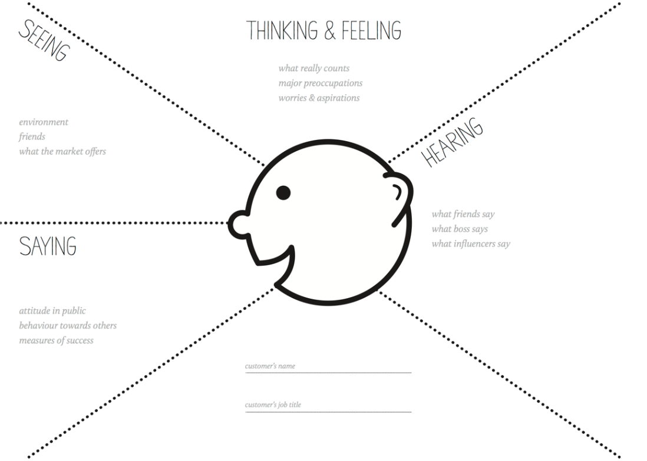

**CUSTOMER EMPATHY MAP**

**Who is your customer?**

**What is your customer:**

1. **Thinking and Feeling?**
2. **Seeing?**
3. **Hearing?**
4. **Saying?**

**PERSONA**

Use the table below (or some other template) to develop your persona description. You may have more than one persona!

|  |  |  |  |
| --- | --- | --- | --- |
| PROFILE | **Location** | *Where does he/she live & work?* |  |
| **Professional** | *What is their job? If B2B, add detail on role in decision making, influence, responsibilities* |  |
| **Education** | *Level and kind of schooling completed* |  |
| BEHAVIORS | **Usage & loyalty** | *Type of usage, online stats, how they engage with us, behavior, usage rate, how loyal* |  |
| **Attitude & Beliefs** | *What does he/she think of us? The category?* |  |
| **Lifestyle** | *Social group, status, openness to innovation, media habits, proficiency* |  |
| **Interests & Hobbies** | *What does he/she do in their free time, how important is that to them?* |  |
| NEEDS | **Usage Goals** | *What is she/he looking to accomplish? How important is it to them?* |  |
| **Emotional Goals / Quote** | *What is at stake emotionally? What would a quote in their words say?* |  |
| **Motivations & Triggers** | *What motivates him/her, what makes them tick?* |  |

**CUSTOMER JOURNEY MAP**

Awareness

Active Client

Refer

Successful Client

Discovery

Engagement

|  |  |  |  |  |  |  |
| --- | --- | --- | --- | --- | --- | --- |
| Customer Touchpoint |  |  |  |  |  |  |
| What do they want to do? What are they looking for? |  |  |  |  |  |  |
| What is the experience we want to create? |  |  |  |  |  |  |
| How can we improve/enhance the experience? |  |  |  |  |  |  |

## SEO

## SEARCH QUERY

## Search Query Analysis: What would potential and current customers type into Google when searching for your business’s products and services? List them below. Google some potential keywords, see what keywords are suggested by Google.

|  |  |
| --- | --- |
|  | Search Query |
| 1 |  |
| 2 |  |
| 3 |  |
| 4 |  |
| 5 |  |
| 6 |  |
| 7 |  |
| 8 |  |
| 9 |  |
| 10 |  |

**KEYWORD ANALYSIS**

Hop onto Google Ads. Use a [keyword search tool](https://adwords.google.com/home/tools/keyword-planner/#?modal_active=none) in Google Ads (under Tools) to analyze the keywords from above by providing the detailed information gathered below. More keyword search tools [here](https://neilpatel.com/blog/10-free-keyword-research-tools-to-help-plan-your-new-site/) and [here](https://moz.com/explorer) and [here](https://www.semrush.com/features/keyword-research/?kw=%2Bsemrush%20%2Btool&cmp=US_SRCH_Brand_Semrush_EN&label=brand_semrush&Network=g&Device=c&utm_content=317119458478&kwid=kwd-102752652316&cmpid=405704596&gclid=CjwKCAjw8df2BRA3EiwAvfZWaFTzB4osgN2n8HTIHeXGSH9J8tSvcN98q-aJcC7E0QEefikrfaaZyxoCjPYQAvD_BwE).

|  |  |  |  |
| --- | --- | --- | --- |
| Search Query | Avg. Monthly Searches | Competition | Avg. Bid |
|  |  |  |  |
|  |  |  |  |
|  |  |  |  |
|  |  |  |  |
|  |  |  |  |
|  |  |  |  |
|  |  |  |  |
|  |  |  |  |
|  |  |  |  |
|  |  |  |  |

D. What is an avg. cost per click in your client’s industry?

E. Based on your research, what keywords will you target for your client? Why? What does the forecast look like? You can use a screenshot for the forecast.

**Helpful Links:**

<https://analytics.moz.com/pro/link-explorer/home>

<https://blog.hubspot.com/marketing/link-building-email-templates>

## SCREAMINGFROG

* 1. Download Screaming Frog Spider on your computer
  2. Enter your company’s website into Screaming Frog.
  3. Look at the various tabs, such as “Page Titles” and “Meta description”
  4. What could you improve? What is missing? See below:
* Write title tags for these 3 pages on your website:
  + - 1. Home page
      2. Product page
      3. About us page
* Evaluate the Title Tags and Meta Descriptions

1. Current Title Tag:
2. Improved Title Tag:
3. Current Meta Description:
4. Improved Meta Description:

* Simulate a search using SERP Snippet Tool (on Screaming Frog).

1. What are your observations?

* Website Specifics
  + - 1. Is the site mobile friendly?
      2. Any broken links?
      3. Load quickly?

**Not required,** but a great tool to use for On-Page SEO:[EXCEL SHEET FOR SEO PLAN](https://www.dropbox.com/s/af4jkq0iagyabra/On-Page%20SEO%20Template%20-%20HubSpot.xlsx?dl=0)

## 

## GOOGLE ADS

There are three main elements of a paid search campaign: keywords, ads, and landing pages. You start out by giving Google a list of keywords, which tells Google to display your ads on the results page when people search for those keywords. You then design your ads to be shown for these keywords, and your goal is to make them both relevant enough to the search query and attractive enough to get the searchers to click on them. Then, when viewers click on your ads, the ads direct them to your landing pages. The goal of your landing pages is to get the

visitor to convert in some way – by buying your product, downloading an offer, etc. So paid search really comes down to managing, matching, and optimizing these three things.

1. Google a keyword or phrase related to your client. Be sure to *exclude* the brand name or name of the organization. Click on a few listings and explore the websites.

## Based on your experience:

## ●      What did you like about some of the ads and links you saw?

## ●      How would you improve the experience?

## ●      What site are you more likely to buy this product from? Why?

## ●      Are these paid ads? How do you know?

1. Make a Google Ads account

3a. Hop onto Google Ads. Use a [keyword search tool](https://adwords.google.com/home/tools/keyword-planner/#?modal_active=none) in Google Ads (under Tools) to

analyze the keywords from above by providing the detailed information gathered below.

More keyword search tools [here](https://neilpatel.com/blog/10-free-keyword-research-tools-to-help-plan-your-new-site/) and [here](https://moz.com/explorer).

|  |  |  |  |
| --- | --- | --- | --- |
| Search Query | Avg. Monthly Searches | Competition | Avg. Bid |
|  |  |  |  |
|  |  |  |  |
|  |  |  |  |
|  |  |  |  |
|  |  |  |  |
|  |  |  |  |
|  |  |  |  |
|  |  |  |  |
|  |  |  |  |
|  |  |  |  |

3b. What is an avg. cost per click in your client’s industry?

3c. Based on your research, what keywords will you target for your client? Why?

## 

## 4a. Think about your client’s target audience and how they search online. Create a campaign strategy (like the one below) with two ad groups for paid search (think about how you will measure success!).

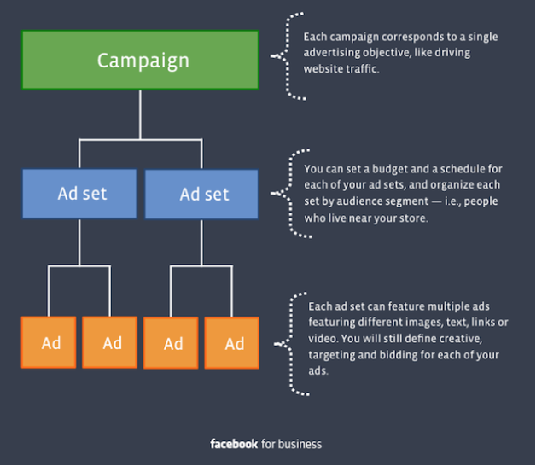

4b. Create your ads and use the layout below:

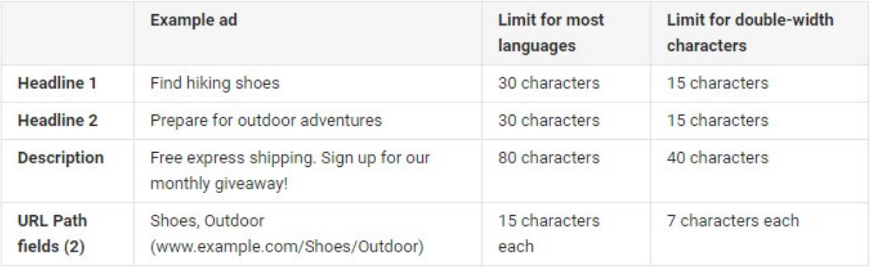

***You should also create these in Google Ads so you can screenshot them and show your client what it will look like on Google.***

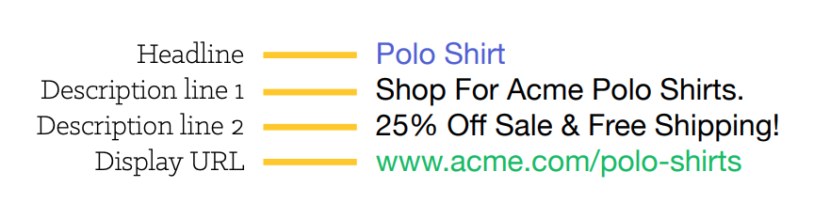

4c. How will you A/B test?

4d. What is your budget to run this campaign?

Here is a great example of how you can present your work:

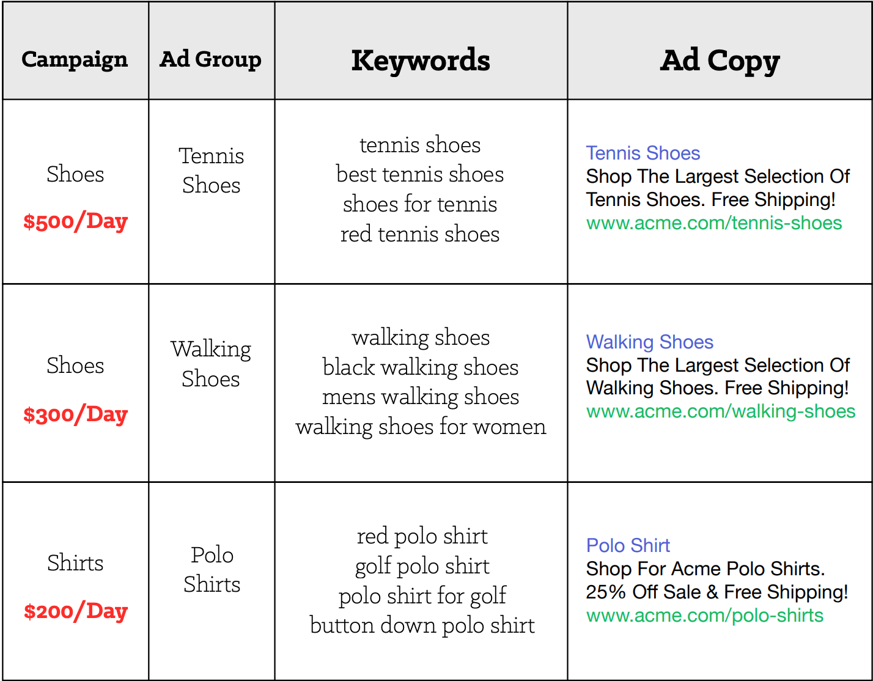

4e. What metrics will you assess to measure success or failure of this ad?

**5. Landing pages**

Paid search is a great way to do landing page A/B testing because it allows you to direct traffic to your choice of pages, split this traffic to different pages, and ultimately find the pages that convert at the highest rate. For example, you can take one ad and actually set it to go to two different destination URLs, and therefore, to two different landing pages. So for a cat food ad, you could have one ad going to a page with one offer (a guide on feeding techniques for your older cat), and the other to a page for another offer (an actual product page for cat food). You could also have the ad go to two different landing pages that are for the same offer. For example, if you wanted to test a feature of your forms, you could have two versions of the same landing page, each with a different form layout, and send the ad to each of those. This is called A/B testing, a very important and highly recommended practice for optimizing your landing pages.

5a. Create two landing pages to test for your ads.

5b. What metrics will you assess to measure success or failure of this landing page?

**SOCIAL MEDIA CONTENT CALENDAR**

Develop a one-week Content Calendar for your brand’s social media accounts. Make sure to provide:

·   Style guide

·   Theme for each day of the week and rationale for theme

·   Copy

·   Photo

·   Link

·   Hashtags

Sample Content Calendar Template: <https://docs.google.com/spreadsheets/d/1oXzSsfqfmgd5CE5-AEb5FtH7uoSmS1V86R7ZnrzszD0/edit#gid=0>

**CONTENT MARKETING**

Identify the buyer’s journey for your primary buyer persona. The goal is to help this buyer through each stage: awareness, consideration, and decision.

1. Awareness stage

In the box below, outline a content format and theme. (Think of this like a working title. What do you want to communicate?)

2. Consideration stage

In the box below, outline a content format and theme. (Think of this like a working title. What do you want to communicate?)

3.Decision stage

In the box below, outline a content format and theme. (Think of this like a working title. What do you want to communicate?)

***TOWNSEND SECURITY EXAMPLE***

*Below is an example of the buyer’s journey Townsend Security identified for its primary buyer persona, Growing Awareness Andy.*

*• Awareness stage:*

*· Content format: Guide*

*· Theme: The Definitive Guide to Encryption Key Management Fundamentals*

*• Consideration stage:*

*· Content format: Webinar*

*· Theme: Encryption Key Management Simplified*

*• Decision stage:*

*· Content format: Product evaluation*

*· Theme: Alliance Key Manager*

**BLOG POST**

Create one (1) blog post for your brand. Include:

* Title
* Copy
* Photos
* CTA
* Keywords
* Links!

Use the samples below for inspiration, but don’t forget to view competitor blogs for ideas.

* <https://www.dropbox.com/sh/luri191jcgupruu/AADhtKfFiTo0oeAl3wN53R-Sa?dl=0>

**FACEBOOK AD**

To do this assignment, you will need a Facebook Business Page so you can access the Meta Ads Manager. If you don’t already have a Business Page for your brand, create one -- this is the only way you can create a Facebook ad. You will not be “boosting posts”.  If you don’t have client access, you can create a hypothetical page to do this assignment and delete it later.

Create a Facebook ad for your brand and include the information below:

* What is the goal/objective of the ad?
* What is the demographic/psychographic of your target audience?
* Show us one sample ad or more in the Facebook Ads Manager. Screenshots work well!
* Create a budget for running your ad.
  + [Budget Calculator](https://docs.google.com/spreadsheets/d/1zE4KvHIsBBIfs2ci2Wk2bbs_UoWoUCAXSa19VBi506Q/edit?_hsenc=p2ANqtz-_Ih7G9N-LmkC8UVh5iAENOZGvd-gIXl8lLJMFHoE3XShFoD9Ipdlpe1yee-q1U3osmOM5lgh1v0DOYiBFNuT09tBC32w&_hsmi=80273350)
* How do you plan to A/B test your ad?
* What is the landing page you will send your audience to? Create one and screenshot. Link should be in the ad you create above.
* What are your KPIs for this ad? [Important Facebook Metrics](https://neilpatel.com/blog/the-5-important-metrics-of-facebook-ad-campaigns/)

[**Sample Social Media Ad Assignment**](https://www.dropbox.com/s/tbdkvkefgfbkb0m/Facebook%20Ads%20Assignment%20Sample.docx?dl=0)

**GOOGLE ANALYTICS**

You have been hired as a digital marketing analyst for Flood It!. Please get familiar with your employer by exploring their mobile app, [Android](https://play.google.com/store/apps/details?id=com.labpixies.flood&hl=en) and [iOS](https://itunes.apple.com/us/app/flood-it!/id476943146?mt=8). Flood It! is a real puzzle game in which you have to flood the whole game board with one color in fewer than the allowed steps. Flood It! has Google Analytics 4 implemented. The mobile app data is flowing to the Google Analytics 4 demo project. The data available is typical of what you might see for a gaming app with in-app purchases.

**Step 1**

Gain access to a Google Analytics 4 demo account for Flood It!. [Instructions for accessing this demo account](https://support.google.com/analytics/answer/6367342?hl=en) are available from Google. Make sure when you access the demo account you navigate to the Property ‘GA4 - Flood-It!’ (see images below).

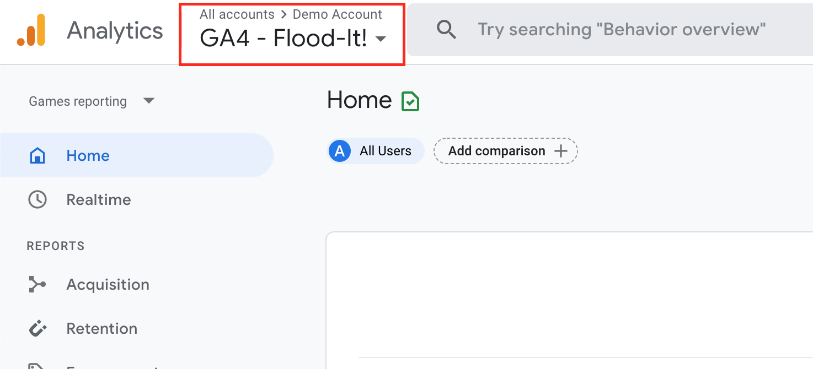

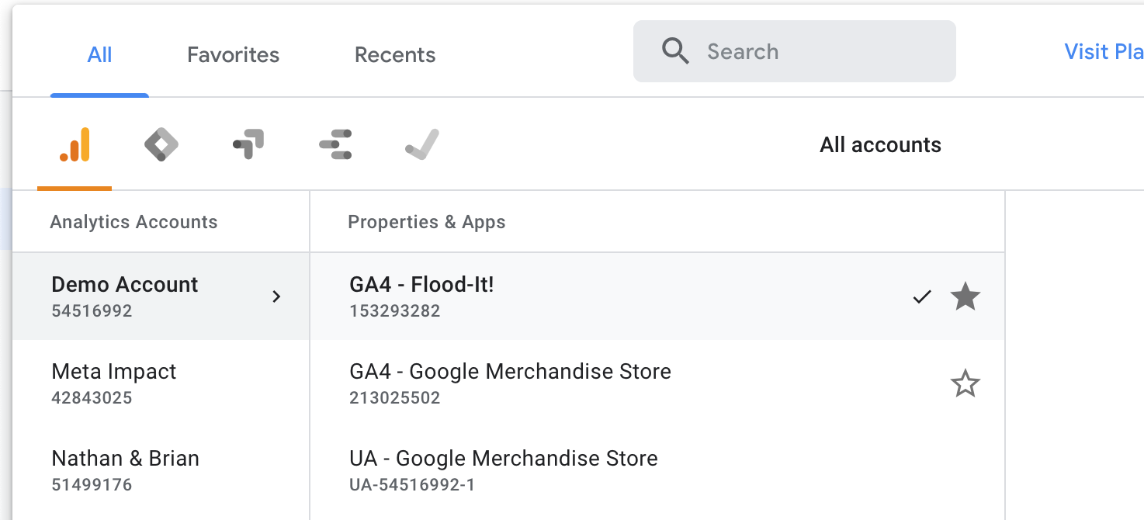

**Step 2**

**Access Google Analytics 4:**

1. Open the Google Analytics 4 dashboard.
2. Adjust the date filter (located in the upper right-hand corner) to cover the period from **July 1, 2022, to July 31, 2022**.

**Step 3**

**Answer the Following Questions:**

Your manager is interested in the mobile app performance for Flood It! for the month of July 2022. When you open the Google Analytics 4 analytics dashboard, make sure you adjust the date filter in the upper right-hand corner to start on July 1, 2022, and end on July 31, 2022. Your manager has asked you to answer the following questions using data from the Google Analytics 4 demo account.

1. How many new users (in thousands) did the Flood It! mobile app have in July 2022?

2. How many new users were acquired through Paid Search in July 2022?

3. How many returning users (in thousands) did the Flood It! mobile app have in July 2022?

4. How many post_score events occurred in July 2022?

5. In minutes and seconds, what was the average engagement time?

6. Which event name had the highest count in July 2022?

7. What was the total revenue in July 2022?

8. What was the average revenue per paying user in July 2022?

9. Flood It! uses first opens as a proxy for app installs. What was the first_open event count in July 2022?

10. How many users visited the app from the United States in July 2022?

**SAMPLE MONTHLY ANALYTICS REPORT TEMPLATE**

Imagine that each month you need to update your client on the status of the various tactics you have implemented. This assignment asks you to create a **sample** monthly analytics report for your client that shares important data about your digital marketing efforts. You won't have access to the actual data of your client, but you can still show the KPIs that are important and show how you will communicate the information visually. For example, if you have tactics related to social media, you would track followers, engagement, reach, etc. If you are suggesting an email campaign, you may track open rates, unsubscribers, CTRs. For website data, you can create a sample dashboard showing key website data on Google Analytics. You can use screenshots from analytics sections of various channel analytics sections, use a dashboard analytics software (Social Report is an example), or create an excel spreadsheet that you can update monthly.Please include the following **based on your tactics**:

* Determine KPIs and create a visual report template sharing the data you would like to share with the client on a monthly basis.
* Add some explanation about what this data means and what recommendations you have for your client moving forward.

***SOCIAL MEDIA TACTIC EXAMPLE***

*[CLIENT NAME] ANALYTICS REPORT*

*[MARCH 20-MARCH 26, 2023]*

*KEY INSIGHTS*

* *Posts including quotes performed 10% better on engagement than all other content*
* *Example*
* *Example*

*ANALYTICS*

|  |  |  |  |  |  |
| --- | --- | --- | --- | --- | --- |
|  | *Followers/count* | *Reach* | *Impressions* | *Engagement* | *Clicks* |
| *Facebook* |  |  |  |  |  |
| *Instagram* |  |  |  |  |  |
| *Twitter* |  |  |  |  |  |

*TOP POSTS*

* *Show one or two posts that did the best this week, Screenshot OK*

GOALS FOR NEXT WEEK

* Start [    ] campaign
* Engage with [specific handles] accounts
* Add one daily Twitter post on the topic of [      ]
* Engage with [   ] influencers for [    ] contest campaign
* Include website link in each post

**EMAIL**

Develop **3 sample emails** for your client, one in each phase of the buyer journey. Remember to include:

* 1. Phase in buyer journey
  2. Email Type
  3. Target Audience
  4. Subject Line
  5. Copy
  6. Include CTA